CAPITALAND SUSTAINABILITY X CHALLENGE 2022
FULL SUBMISSION FORM

Title of Proposal:

Please indicate the challenge statement that you are submitting for: Low Carbon Transition (2)
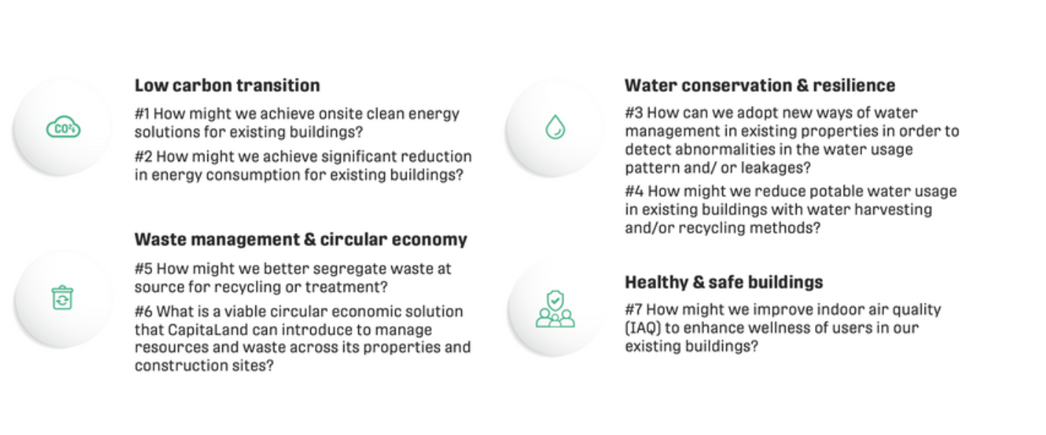

Does your solution meet the following requirements?
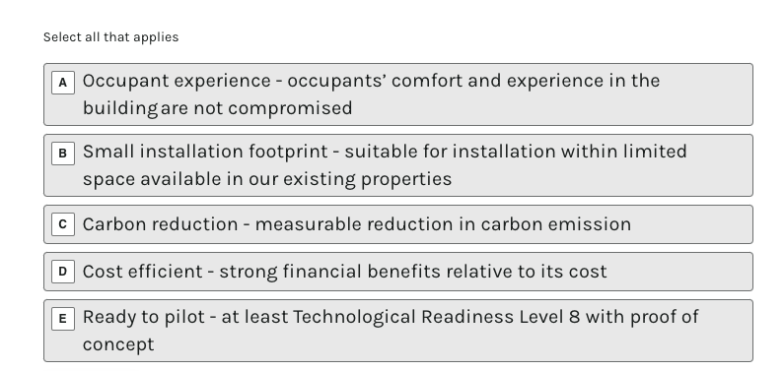

Competitive advantage of proposed solution
Please list down your 3 unique selling points
(150 words)
Ambient provides balanced CRE optimization & decarbonization through three unique features.
First feature is Flexible On-demand Subscription, enabling CRE asset managers to leverage our data science solution with no additional employee onboarding, training, and manpower reliance. Second is Simple and Affordable Pricing Plans, circumventing reliance on expensive data science consultancies or in-house teams. Third is Specialized AI Model customization, allowing asset managers to reach their portfolio goals across energy efficiency, environment, and compliance using Ambient’s state of the art machine learning models.

5 Description of Proposal *
Please include its main features, benefits to CapitaLand assets, and deployment strategy
(200 words)
Ambient proposes to work with CapitaLand’s Data Centre, Sustainability, and Property Management teams to drive decarbonization of key portfolio assets. The POC duration can range from 3 to 4 months in length, implementing strategies for achieving effective decarbonization while maintaining asset value and lease yields, among other criteria. Ambient and CapitaLand would work together to identify a property or a section of a property where this can be performed. One option could be a collaboration with NUS Enterprise since Ambient has been working within the NUS ecosystem since its early days in 2020. Moreover, NUS Enterprise's new AgTech centre has deployed latest state of the art BMS/BAS technologies within CapitaLand’s facilities, providing a streamlined way to perform necessary data collection and analytics with minimal hardware upgrades (if any).

6 Stage of solution development*
Please indicate which Technology Readiness Level (TRL) your project is at. You can find more information on TRL here.

7 Company Name *
If you are working with another organization for this project, please include the organization’s name (e.g., XXX in partnership with YYY)
Ambient is a deep tech spinoff from National University’s of Singapore’s Graduate Research and Innovation Programme (NUS GRIP). However, we are also currently incubated at SMU. We would be open to working with proprety and facility managers at these facilities if they fall within CapitaLand’s property portfolio.

8 Company Website *
https://www.ambientsystems.ai/

9. What is your latest funding stage?
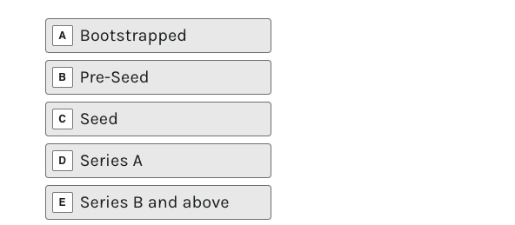

10 Country of Incorporation *
Singapore

11 Countries of Business Operations *
Singapore

12 Name of Project Leader *
Ivan Damnjanović

13 [Third party] of Project Leader *
ivan@ambientsystems.ai

14 Contact Number of Project Leader *
[phone redacted]

15 Innovation
- Proposed Solution*
1. What are the technologies/ideals underpinning the proposal?

The solution is developed and deployed on the cloud, using a combination of cloud computing service providers. There is a hardware component to the solution that might be needed for some facilities. It’s essentially a gateway that plugs into the building’s BMS/BAS to access the needed data and subsequently provide controls. The rest of the solution, including the databases and machine learning models are based on the cloud. Data feeds are accessed through standard APIs.
2. How is your solution applicable and suitable to CapitaLand properties?

As a leader in commercial real estate asset management, CapitaLand is tasked with managing a diverse range of real estate asset classes. This requires an experienced team of property managers and partners to ensure asset portfolio strategy is reflected in the day-to-day building operations. Fragmented data and multiple applications make this a difficult and time intensive process, requiring manual effort to collate and validate date before analytics is performed. Ambient’s solution streamlines this process, aggregating property-level data into portfolio-level insights and strategic recommendations towards decarbonization. Our methodology is unique because we not only consider operational carbon emitted from energy and water consumption, but also scope 2 and 3 carbon from upstream and downstream activities as well as the overall business objectives of the tenants within the facilities. In other words, we balance sustainability (decarbonization) objectives with business realities of asset managers, operators, and occupiers through data-driven approach levering state of the art machine learning models and other data science techniques.
3. What preliminary studies have been established to demonstrate efficacy of the solution?
(100 words each)

We have completed POC with an industrial company in Singapore, demonstrating the opportunity to enhance production of the business operations while improving sustainability and decarbonization of the overall facility. At the same time, we developed a machine learning model that performs multi-objective optimization towards decarbonization. This model is developed through a combination of proprietary data, open-source data, and simulated data. We can conduct a similar analysis for CapitaLand property where additional simulated or open-source data is needed to augment the available datasets.

16 Impact
- Impact of Proposed Solution *
Please explain how you expect your solution to perform and how you will evaluate and measure impact.
Format: Metric X, [Third party], Year X; [Third party], [Third party] Y, Year Y; Metric Z, [Third party] Z, Year Z, etc.

There are multiple metrics we can evaluate in order to measure the impact of the solution.

We would look at asset value and carbon emissions (operational and embodied, which is often referred to as Scope 1, 2, or 3 emissions) as our primary metrics. This would be benchmarked against a baseline year for the first year of assessment.

We would also consider other important criteria such as tenant satisfaction, lease yields, and other property or portfolio level metrics important to CapitaLand.

- Please quantify the estimated capex cost of implementation *
Please state the cost in SGD and include your basis of estimates

CAPEX would vary based on the technical readiness of the facility. We might need to install an on-site gateway to connect the BMS and any other sensor or control networks at the facility. This is not sold by Ambient but vendor's are likely to ask for $10k-$20k for a medium sized facility.

We would also need an additional $30k for deployment of the cloud-based web application, including the machine learning model that evaluates the data and generates property and portfolio level insights.

- Please quantify the estimated opex cost per month *
Please state the cost in SGD and include your basis of estimates

OPEX would be tied to the computing requirements needed at the property, meaning it’s proportional to the data management requirements. Our solution will likely cost $1k to $2k per month per facility, depending on the amount of data processed and complexity of machine learning insights deployed.

- Please quantify the estimated cost of reduction or avoidance per month *
Please state the cost in SGD and include your basis of estimates

Our previous POC and machine learning model outputs indicate potential cost benefits across the following categories: 15-30% energy savings, 20-40% reduction in carbon emissions, and 3x time savings on facility management and supporting technical services and skilled trades fees.

- Is the lifecycle carbon emission of the proposed solution significantly lower than the market norm? *

Yes, Ambient’s solution can progressively move the portfolio towards net-zero while maintaining or enhancing asset value and yields.

- What will success look like when your solution is eventually developed and commercialised? *

Our success would be to deliver value to CapitaLand’s property and portfolio teams through data science. We want to demonstrate a fully deployed and trained machine learning application for decarbonization of CRE. We have built the technology through 2+ years of incubation at NUS and would need to partner with commercial institutions such as CapitaLand to move forward. If we can achieve this we would not only be delivering to CapitaLand but also potentially to other CRE asset managers in Asia and globally.

17. Potential to Scale
a. Which property type can the solution be implemented in? *
b. Can the solution be implemented in various countries? *
c. Viable commercial application of proposed solution

Please explain:
1. Your go-to-market strategy for your solution and who your potential customers would be.

Our go-to-market strategy is to complete 3-5 POC projects in Singapore with local CRE asset managers such as CapitaLand, JTC, SMRT, and Changi Airport Group. In parallel we plan to start conversation with large CRE asset managers in Asia and globally. Our ideal customers would be portfolio management teams at GLP (Singapore), IGIS Asset Management (Seoul), ESR (Hong Kong), Blackstone (USA), and Brookfield (Toronto). These five leading real estate asset managers have around $200B of assets under management in Asia with further portfolio in USA, Canada, and Europe, which are our eventual long-term markets.
2. The expected price point of the solution (if applicable) and how this will be achieved.
(150 words each)

OPEX would be tied to the computing requirements needed at the property, meaning it’s proportional to the data management requirements. Our solution will likely cost $1k to $2k per month per facility, depending on the amount of data processed and complexity of machine learning insights deployed.

d. Current competing technologies/co/competitors *

Based on our market research, it seems the only way for companies like CapitaLand to deploy data science solutions for their CRE property portfolio is through building an in-house data science team or hiring consultancies. However, these have many drawbacks in terms of cost, time-to-solution, and industry specific applications. Moreover, BMS and IoT systems alone are not enough and are simply a data collection layer needed for broader data science initiatives. Most BMS and IoT companies rarely have the data science capabilities that top consultancies have since they’re constrained by tight margin electronics manufacturing and installation costs that comprise the bulk of their business revenues. Finally, data scientists are in high-demand and short supply – with more job postings than talent available. The top ones are usually employed by tech giants or consultancies. This combination of factors makes it difficult to adopt and deploy data science solutions for modelling needed for the CRE industry.

e. Has the technology received or applied for a patent? *

Yes, we have a patent-pending invention filed in Singapore. The founder is the sole inventor.

- Can you state any case studies related to projects that were completed / are ongoing with clients or partners to show your track record (if any) (This can include third party verifications, certifications, or expert papers/analysis.)

We worked with a few industrial facilities in Singapore to collect data and develop industry-specific models to improve their business through enhanced building operations via BMS/BAS and supporting IoT systems. Most of the facilities we worked with were indoor farms in Singapore, so we had to work under tight space and budget constraints. We also spoke with some of the leading healthcare facility management firms in the region (Parkway Pantai) and identified a need for Ambient’s solution. However, we need to grow the company before we can deliver a solution to larger and more complex facilities such as hospitals. That's why we think this POC will help position us to provide a complete commercial solution to various real estate asset types.

18. General Declaration
a. If your proposal has received funding from institutions/government bodies, please state the entity name and date of funding application. *

National University of Singapore's deep tech incubator: S$ 100k in two tranches following company incorporation in July 2021

- Is the proposal subject to any ethics or regulatory approval requirements? *

- I declare that my company/myself has the legal ownership of technology/IP for the proposed solution *

- Has the proposal used, or will it be using, any intellectual property or licenses from third parties? *

19. Additional supporting documents for proposal

